**Q1. Which of the following step / assumption in regression modeling impacts the trade-off between under-fitting and over-fitting the most.**

A. The polynomial degree

B. Whether we learn the weights by matrix inversion or gradient descent

C. The use of a constant-term

**Solution: A**

**Q2. Suppose you have the following data with one real-value input variable & one real-value output variable. What is leave-one out cross validation mean square error in case of linear regression (Y = bX+c)?**

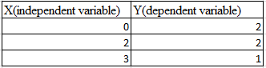

A. 10/27

B. 20/27

C. 50/27

D. 49/27

**Solution: D**

**Q3. Which of the following is/ are true about  “Maximum Likelihood estimate (MLE)”?**

1. **MLE may not always exist**
2. **MLE always exists**
3. **If MLE exist, it (they) may not be unique**
4. **If MLE exist, it (they) must be unique**

A. 1 and 4

B. 2 and 3

C. 1 and 3

D. 2 and 4

**Solution: C**

**Q8. Which of the following indicates a fairly strong relationship between X and Y?**

A. Correlation coefficient = 0.9

B. The p-value for the null hypothesis Beta coefficient =0 is 0.0001

C. The t-statistic for the null hypothesis Beta coefficient=0 is 30

D. None of these

**Solution: A**

**Q15. Suppose you are training a linear regression model. Now consider these points.**

1. **Overfitting is more likely if we have less data**
2. **Overfitting is more likely when the hypothesis space is small**

Which of the above statement(s) are correct?

A. Both are False

B. 1 is False and 2 is True

C. 1 is True and 2 is False

D. Both are True

**Solution: C**

**Q19. The following visualization shows the fit of three different models (in blue line) on same training data. What can you conclude from these visualizations?**

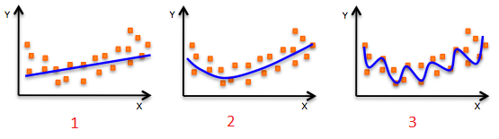

1. **The training error in first model is higher when compared to second and third model.**
2. **The best model for this regression problem is the last (third) model, because it has minimum training error.**
3. **The second model is more robust than first and third because it will perform better on unseen data.**
4. **The third model is overfitting data as compared to first and second model.**
5. **All models will perform same because we have not seen the test data.**

A. 1 and 3

B. 1 and 3

C. 1, 3 and 4

D. Only 5

**Solution: C**

**Q22. The expected value of Y is a linear function of the X(X1,X2….Xn) variables and regression line is defined as:**

**Y = β0 +  β1 X1 + β2 X2……+ βn Xn**

**Which of the following statement(s) are true?**

1. **If Xi changes by an amount ∆Xi, holding other variables constant, then the expected value of Y changes by a proportional amount βi ∆Xi, for some constant βi (which in general could be a positive or negative number).**
2. **The value of βi is always the same, regardless of values of the other X’s.**
3. **The total effect of the X’s on the expected value of Y is the sum of their separate effects.**

**Note: Features are independent of each others(zero interaction).**

A. 1 and 2

B. 1 and 3

C. 2 and 3

D. 1,2 and 3

**Solution: D**

**Q34. How does number of observations influence overfitting? Choose the correct answer(s).**

**Note: Rest all parameters are same**

1. **In case of fewer observations, it is easy to overfit the data.**
2. **In case of fewer observations, it is hard to overfit the data.**
3. **In case of more observations, it is easy to overfit the data.**
4. **In case of more observations, it is hard to overfit the data.**

A. 1 and 4

B. 2 and 3

C. 1 and 3

D. None of theses

**Solution: A**

**Q42. Logistic Regression transforms the output probability to be in a range of [0, 1]. Which of the following function is used by logistic regression to convert the probability in the range between [0,1].**

A. Sigmoid

B. Mode

C. Square

D. Probit

**Solution: A**

Sigmoid function is used to convert output probability between [0,1] in logistic regression.

**Q45. Below are two different logistic models with different values for β0 and β1.**

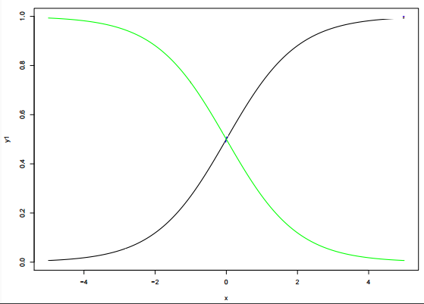

**Which of the following statement(s) is true about β0 and β1 values of two logistics models (Green, Black)?**

**Note: consider Y = β0 + β1*X.  Here, β0 is intercept and  β1 is  coefficient.**

A. β1 for Green is greater than Black

B. β1 for Green is lower than Black

C. β1 for both models is same

D. Can’t Say.

**Solution: B**